15-11-2021

Submitted by:

PALASH BAJPAI

B180759CS

Submitted to:

Dr. Sreejith SS­

**HRA   
Turnover Intention at BenzInfotech  
Assignment**

**TABLE OF CONTENTS**

1. Case Analysis 2

1.1 Case Summary 2

1.2 Decision Summary 2

1.3 Tools for Data Analysis 2

1.4 Dataset 3

2 ANALYSIS 6

2.1 Binomial Logistic Regression Model 6

2.2 Generic/Full Model 6

2.2.1 Binomial Logistic Regression: Model 6

2.3 Reduced / Working Model 8

2.4 Model Comparison 9

2.5 Model Specific Results 10

2.5.1 Model 1 (Reduced / Working Model ) 10

2.5.2 Model 1 (Generic / Full Model ) 13

3. Conclusions 16

Turnover Intention at BenzInfotech

# 1. Case Analysis

## 1.1 Case Summary



BenzInfotech is a company that offers IT solutions for its clients. They've started to experience an increase in attrition rates from the past two quarters. BenzInfotech was not able to identify the reason behind this higher turnover rate. They offer benefits such as Employee Awards, Onsite Opportunities, Flexible Working hours, etc.

## 1.2 Decision Summary

The company wants to know the reason for the high attrition rates. For this reason, they have engaged an MBA intern from a third-party organization to conduct a fair survey among employees. The company wants to know factors that they can work on to decrease the turnover rate. It is proposed to develop a regression model to know factors affecting intentions to stay or leave the company.

## 1.3 Tools for Data Analysis

Jamovi (1.6.23 Solid version) is an open-source software used for the analysis.

## 1.4 Dataset

The survey has compiled the data of about 361 employees of BenzInfotech. The variables are shown in table below.

Table 1: Variables

|  |  |  |  |
| --- | --- | --- | --- |
| **SL . No** | **Variable Name** | **Variable Type** | **Variable Description** |
| 1. | Sl. No | ID | The number provided to each entry in serial order |
| 2. | Gender | Nominal  (Categorical) | Gender of the employee |
| 3. | Boss Gender | Nominal  (Categorical) | Gender of the Boss for each corresponding employee |
| 4. | Tenure | Nominal | Years in organizations |
| 5. | Account | Nominal | The regional account where they are associated at (APAC- Asia Pacific; MEA – Middle East and Africa; UKNA- United Kingdom and North America; LA – Latin America; EU – European Union) |
| 6. | Level | Nominal | Designation Level |
| 7. | Performance Rating | Nominal | Previous Year Performance Score (scale of 1-5; 5 being highest) |
| 8. | Job Satisfaction | Nominal | The satisfaction level in their job (from another survey on a scale of 1-5; 5 being highest) |
| 9. | Engagement | Nominal | The employee engagement level (from another survey on a scale of 1-5; 5 being highest) |
| 10. | LeavesPreYear | Nominal | The number of leaves availed by employees during previous one year |
| 11. | OnsiteOppurtunity | Nominal | Whether or not the employees have got an onsite opportunity |
| 12. | Awards | Nominal | Whether or not the employee received any award from BenzInfotech |
| 13. | Flexihours | Nominal | A benefit offered to employees – whether or not employees are permitted to work during flexible hours |
| 14. | Intention | Nominal | The turnover intention (Yes indicates, the employee is thinking to move out) |

Table 2: Descriptive Statistics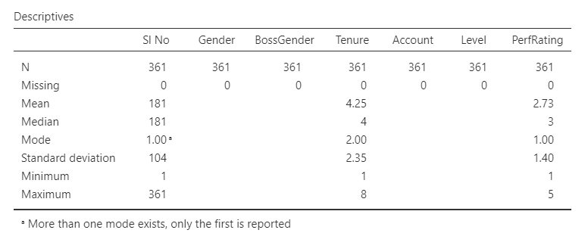

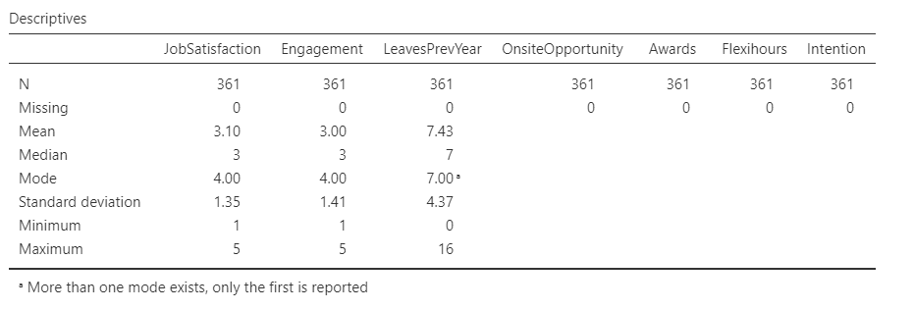

Figure 1: Descriptive Plots

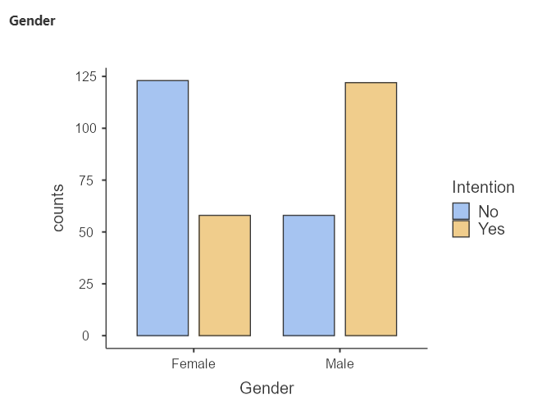

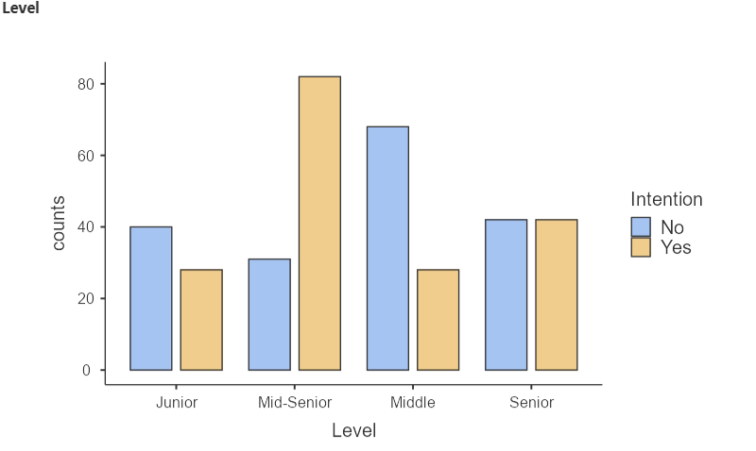

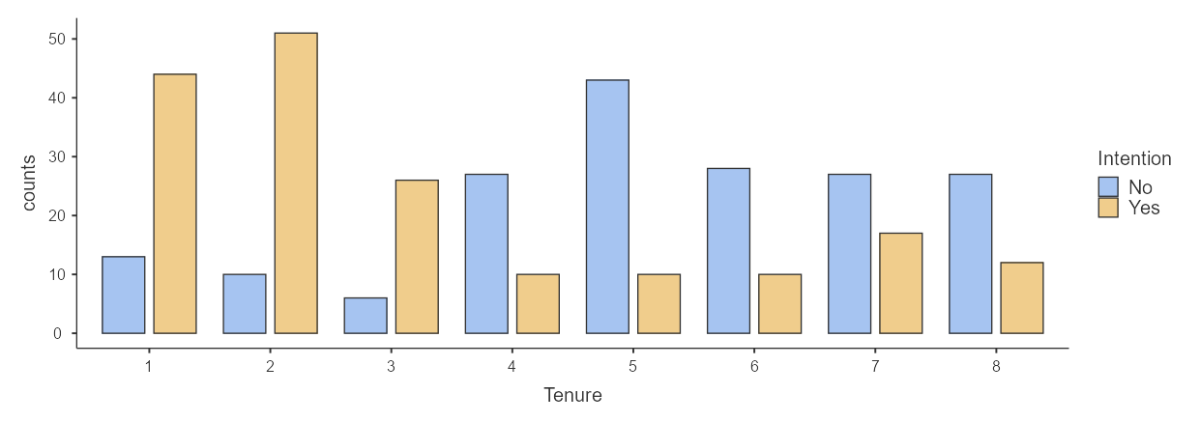

# 2 ANALYSIS

## 2.1 Binomial Logistic Regression Model

Log (yes/1 − yes) = a + b1 (x1 ) + ⋯ + bn( xn)

## 2.2 Generic/Full Model

Intention = a + b1 (Gender) + b2 (Boss Gender) + b3 (Tenure) + b4 (Account) + b5 (Level) + b6 (Performance Rating) + b7 (Job Satisfaction) + b8 (Engagement) + b9 (LeavesPerYear) + b10(Onsite Opportunity) + b11(Awards) + b12(Flexihours)

### 2.2.1 Binomial Logistic Regression: Model

Table 3: Generic Model Fit Measures

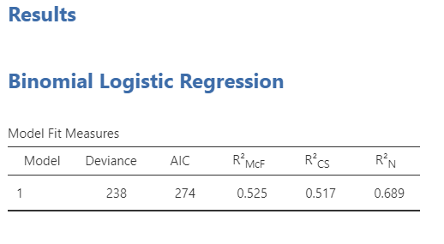

It can be observed from the given table that the AIC (Akaike information criterion) value is 274. A lower AIC value indicates a better fit. The pseudo-R² values, i.e., McFadden's R² is 0.525, Cox and Snell's R² is 0.517, Nagelkerke's R² is 0.689.

Table 4: Generic Model Coefficients

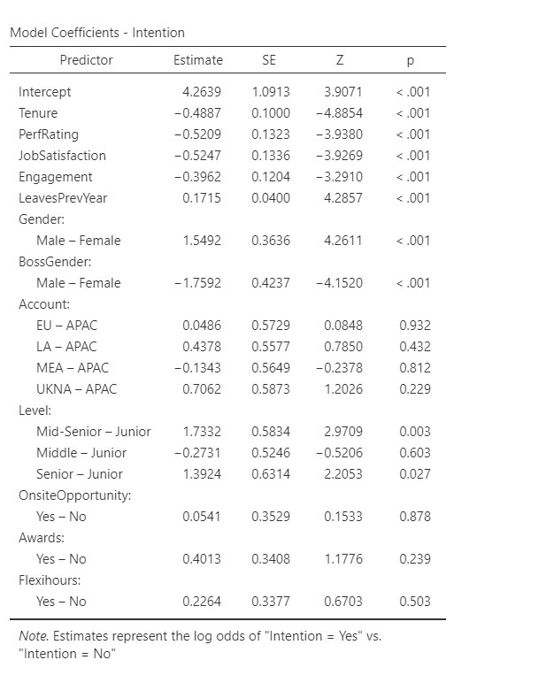

It can be observed from the above table that the p value at 95% confidence level is not significant for 4 variables namely Account, Awards, OnsiteOpportunity, Flexihours. The p values for other variables are significant.

Interpretation of estimate values for the significant variables is as follows,

• If the sign of estimate value for a variable is positive, it indicates that more the value of variable more is chance of having the intention to leave. In brief, these variables affect intention positively.

• If the sign of estimate value for a variable is negative, it indicates that the more the value of the variable lesser is chance of having the intention to leave. In brief, these variables affect intention negatively.

## 2.3 Reduced / Working Model

Intention = a + b1 (Gender) + b2 (Boss Gender) + b3 (Tenure) + b4 (Performance Rating) + b5 (Job Satisfaction) + b6 (Engagement) + b7 (LeavesPerYear) +b8 (Level)

Intention = 4.661 + 1.673 (Gender) -1.816 (Boss Gender) – 0.476 (Tenure) -0.509 (Performance Rating) – 0.503(Job Satisfaction) -0.392(Engagement) + 0.170 (LeavesPerYear) + 1.653(Level) 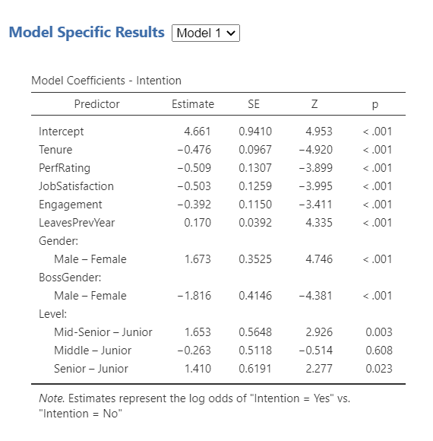

## 2.4 Model Comparison

Table 5: Model Fit Measure (Model 1 and 2)

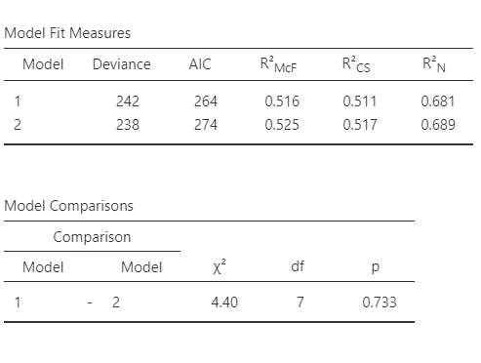

In Table 5, Model 1 represents the reduced/working model and Model 2 represents the generic/full model. It can be observed that the AIC (Akaike information criterion) value is 264 for Model 1. The AIC value obtained for the reduced model is lower than that of the generic model. A lower AIC value indicates a better fit. The pseudo-R² values. McFadden's R² is 0.516, Cox and Snell's R² is 0.511, Nagelkerke's R² is 0.681. The Nagelkerke's R² value for Model 1 is only slightly less than the value of Model 2, hence, the reduced model with 7 variables holds good for prediction.

From the Model Comparisons table, we can see that p-value indicates that the difference between the 2 models is not significant. Therefore model 1 with 7 variables is good to predict intentions.

## 2.5 Model Specific Results

## 2.5.1 Model 1 (Reduced / Working Model )

Intention = 4.661 + 1.673 (Gender) -1.816 (Boss Gender) – 0.476 (Tenure) -0.509 (Performance Rating) – 0.503(Job Satisfaction) -0.392(Engagement) + 0.170 (LeavesPerYear) + 1.653(Level)

1. Model Cofficients

| Model Coefficients – Intention | | | | | | | | | |
| --- | --- | --- | --- | --- | --- | --- | --- | --- | --- |
|  |  |  |  |  |  |  |  |  |  |
| **Predictor** | | **Estimate** | | **SE** | | **Z** | | **P** | |
| Intercept |  | 4.661 |  | 0.9410 |  | 4.953 |  | < .001 |  |
| Tenure |  | -0.476 |  | 0.0967 |  | -4.920 |  | < .001 |  |
| PerfRating |  | -0.509 |  | 0.1307 |  | -3.899 |  | < .001 |  |
| JobSatisfaction |  | -0.503 |  | 0.1259 |  | -3.995 |  | < .001 |  |
| Engagement |  | -0.392 |  | 0.1150 |  | -3.411 |  | < .001 |  |
| LeavesPrevYear |  | 0.170 |  | 0.0392 |  | 4.335 |  | < .001 |  |
| Gender: |  |  |  |  |  |  |  |  |  |
| Male – Female |  | 1.673 |  | 0.3525 |  | 4.746 |  | < .001 |  |
| BossGender: |  |  |  |  |  |  |  |  |  |
| Male – Female |  | -1.816 |  | 0.4146 |  | -4.381 |  | < .001 |  |
| Level: |  |  |  |  |  |  |  |  |  |
| Mid-Senior – Junior |  | 1.653 |  | 0.5648 |  | 2.926 |  | 0.003 |  |
| Middle – Junior |  | -0.263 |  | 0.5118 |  | -0.514 |  | 0.608 |  |
| Senior – Junior |  | 1.410 |  | 0.6191 |  | 2.277 |  | 0.023 |  |
| Note. Estimates represent the log odds of "Intention = Yes" vs. "Intention = No" | | | | | | | | | |
|  | | | | | | | | | |

2. Assumption Check

We see Tenure is having more VIF (Variation Inflation Factor) value than other variables hence it affects intention more in comparison of others. For ideal case tolerance should be less than 1 and VIF should be less than 3.

| Collinearity Statistics | | | | | |
| --- | --- | --- | --- | --- | --- |
|  |  |  |  |  |  |
|  | | **VIF** | | **Tolerance** | |
| Tenure |  | 1.30 |  | 0.769 |  |
| PerfRating |  | 1.07 |  | 0.936 |  |
| JobSatisfaction |  | 1.02 |  | 0.979 |  |
| Engagement |  | 1.02 |  | 0.983 |  |
| LeavesPrevYear |  | 1.02 |  | 0.979 |  |
| Gender |  | 1.10 |  | 0.913 |  |
| BossGender |  | 1.03 |  | 0.971 |  |
| Level |  | 1.10 |  | 0.911 |  |
|  | | | | | |

3. Prediction

| Classification Table – Intention | | | | | | | |
| --- | --- | --- | --- | --- | --- | --- | --- |
|  | | **Predicted** | | | |  | |
| **Observed** | | **No** | | **Yes** | | **% Correct** | |
| No |  | 155 |  | 26 |  | 85.6 |  |
| Yes |  | 29 |  | 151 |  | 83.9 |  |
| Note. The cut-off value is set to 0.5 | | | | | | | |
|  | | | | | | | |

The observed or actual intention has been shown in above table using the working model. The correctness percentage of no intention is 85.6%, this is the specificity. The correctness percentage of intention yes is 83.9%, this is the sensitivity.

| Predictive Measures | | | | | | | |
| --- | --- | --- | --- | --- | --- | --- | --- |
|  |  |  |  |  |  |  |  |
| **Accuracy** | | **Specificity** | | **Sensitivity** | | **AUC** | |
| 0.848 |  | 0.856 |  | 0.839 |  | 0.930 |  |
| Note. The cut-off value is set to 0.5 | | | | | | | |
|  | | | | | | | |

The Accuracy of the working model is 0.848. Thus our model with 8 variables can predict with 84.8% accuracy whether the employee has the intention to leave the company or not. Specificity measures the proportion of true negatives, i.e., 0.856. Sensitivity measures the proportion of true positives that are correctly identified, i.e., 0.839. The AUC (Area Under the Curve) value is 0. 930.The higher the AUC i.e., close to 1, the better the performance of the model.

The ROC (Receiver Operating Characteristic) curve shows the relationship between sensitivity and 1-specificity for possible cut-off.

##### ROC Curve

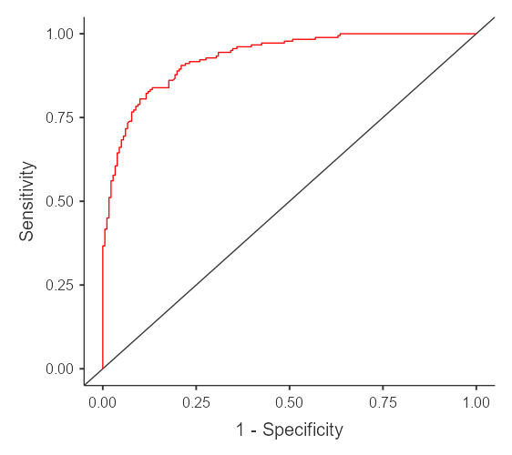

## 2.5.2 Model 1 (Generic / Full Model )

1. Model Cofficients

| Model Coefficients – Intention | | | | | | | | | |
| --- | --- | --- | --- | --- | --- | --- | --- | --- | --- |
|  |  |  |  |  |  |  |  |  |  |
| **Predictor** | | **Estimate** | | **SE** | | **Z** | | **p** | |
| Intercept |  | 4.2639 |  | 1.0913 |  | 3.9071 |  | < .001 |  |
| Tenure |  | -0.4887 |  | 0.1000 |  | -4.8854 |  | < .001 |  |
| PerfRating |  | -0.5209 |  | 0.1323 |  | -3.9380 |  | < .001 |  |
| JobSatisfaction |  | -0.5247 |  | 0.1336 |  | -3.9269 |  | < .001 |  |
| Engagement |  | -0.3962 |  | 0.1204 |  | -3.2910 |  | < .001 |  |
| LeavesPrevYear |  | 0.1715 |  | 0.0400 |  | 4.2857 |  | < .001 |  |
| Gender: |  |  |  |  |  |  |  |  |  |
| Male – Female |  | 1.5492 |  | 0.3636 |  | 4.2611 |  | < .001 |  |
| BossGender: |  |  |  |  |  |  |  |  |  |
| Male – Female |  | -1.7592 |  | 0.4237 |  | -4.1520 |  | < .001 |  |
| Level: |  |  |  |  |  |  |  |  |  |
| Mid-Senior – Junior |  | 1.7332 |  | 0.5834 |  | 2.9709 |  | 0.003 |  |
| Middle – Junior |  | -0.2731 |  | 0.5246 |  | -0.5206 |  | 0.603 |  |
| Senior – Junior |  | 1.3924 |  | 0.6314 |  | 2.2053 |  | 0.027 |  |
| Account: |  |  |  |  |  |  |  |  |  |
| EU – APAC |  | 0.0486 |  | 0.5729 |  | 0.0848 |  | 0.932 |  |
| LA – APAC |  | 0.4378 |  | 0.5577 |  | 0.7850 |  | 0.432 |  |
| MEA – APAC |  | -0.1343 |  | 0.5649 |  | -0.2378 |  | 0.812 |  |
| UKNA – APAC |  | 0.7062 |  | 0.5873 |  | 1.2026 |  | 0.229 |  |
| OnsiteOpportunity: |  |  |  |  |  |  |  |  |  |
| Yes – No |  | 0.0541 |  | 0.3529 |  | 0.1533 |  | 0.878 |  |
| Awards: |  |  |  |  |  |  |  |  |  |
| Yes – No |  | 0.4013 |  | 0.3408 |  | 1.1776 |  | 0.239 |  |
| Flexihours: |  |  |  |  |  |  |  |  |  |
| Yes – No |  | 0.2264 |  | 0.3377 |  | 0.6703 |  | 0.503 |  |
| Note. Estimates represent the log odds of "Intention = Yes" vs. "Intention = No" | | | | | | | | | |
|  | | | | | | | | | |

2. Assumption Check

We see Tenure is having more VIF (Variation Inflation Factor) value than other variables hence it affects intention more in comparison of others. For ideal case tolerance should be less than 1 and VIF should be less than 3.

| Collinearity Statistics | | | | | |
| --- | --- | --- | --- | --- | --- |
|  |  |  |  |  |  |
|  | | **VIF** | | **Tolerance** | |
| Tenure |  | 1.34 |  | 0.747 |  |
| PerfRating |  | 1.07 |  | 0.932 |  |
| JobSatisfaction |  | 1.07 |  | 0.935 |  |
| Engagement |  | 1.05 |  | 0.954 |  |
| LeavesPrevYear |  | 1.03 |  | 0.971 |  |
| Gender |  | 1.12 |  | 0.894 |  |
| BossGender |  | 1.04 |  | 0.957 |  |
| Level |  | 1.13 |  | 0.885 |  |
| Account |  | 1.05 |  | 0.951 |  |
| OnsiteOpportunity |  | 1.09 |  | 0.921 |  |
| Awards |  | 1.05 |  | 0.954 |  |
| Flexihours |  | 1.04 |  | 0.963 |  |
|  | | | | | |

3. Prediction

| Classification Table – Intention | | | | | | | |
| --- | --- | --- | --- | --- | --- | --- | --- |
|  | | **Predicted** | | | |  | |
| **Observed** | | **No** | | **Yes** | | **% Correct** | |
| No |  | 158 |  | 23 |  | 87.3 |  |
| Yes |  | 29 |  | 151 |  | 83.9 |  |
| Note. The cut-off value is set to 0.5 | | | | | | | |
|  | | | | | | | |

The observed or actual intention has been shown in above table using the working model. The correctness percentage of no intention is 85.6%, this is the specificity. The correctness percentage of intention yes is 83.9%, this is the sensitivity.

| Predictive Measures | | | | | | | |
| --- | --- | --- | --- | --- | --- | --- | --- |
|  |  |  |  |  |  |  |  |
| **Accuracy** | | **Specificity** | | **Sensitivity** | | **AUC** | |
| 0.856 |  | 0.873 |  | 0.839 |  | 0.932 |  |
| Note. The cut-off value is set to 0.5 | | | | | | | |
|  | | | | | | | |

The Accuracy of the generic model is 0.856. Thus our model with 12 variables can predict with 85.6% accuracy whether the employee has the intention to leave the company or not. Specificity measures the proportion of true negatives, i.e., 0.873. Sensitivity measures the proportion of true positives that are correctly identified, i.e., 0.839. The AUC (Area Under the Curve) value is 0. 932.The higher the AUC i.e., close to 1, the better the performance of the model.

ROC Curve

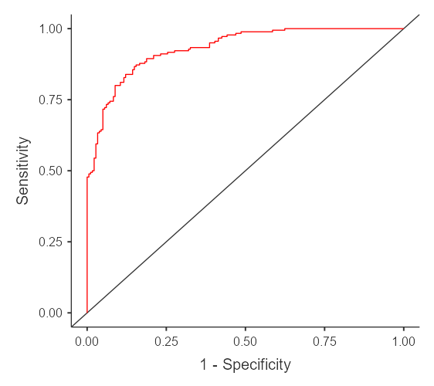

# 3. Conclusions

We have developed our model with 8 variables that affect the intention most. For this prediction, we applied Binomial Logistic Regression on the dataset collected through a survey on Employees of BenzInfotech.

**Intention = 4.661 + 1.673 (Gender) -1.816 (Boss Gender) – 0.476 (Tenure) -0.509 (Performance Rating) – 0.503(Job Satisfaction) - 0.392(Engagement) + 0.170 (LeavesPerYear) + 1.653(Level)**

Observations :-

• Male employees tend to have more turnover intention than females.

• Employees with Female bosses tend to have lesser turnover intentions.

• Employees with more leaves per year tend to have more turnover intentions.

• Employees with lesser tenure, less performance rating, less job satisfaction, less engagement tend to have more turnover intentions.

Strategies to reduce turnover intentions:-

• The company should include some more policies to help employees to perform better in their work. More performance rating lesser will be turnover intentions.

• Should train male bosses to learn how female bosses behave with employees working under them.

• Bring changes in working culture to improve job satisfaction among employees .